Tax-Aide Appointment System
Installation and Configuration Manual
September 8, 2022
Version 8.02
This appointment system (referred to in this document as TAAS) was developed by AARP Foundation Tax-Aide volunteers from Colorado to replace paper or spreadsheet type systems. It provides a convenient platform for managing appointments for individual sites, coordination of scheduling across multiple sites, or a central scheduling point for many sites. New sites and users can be added by any Appointment Manager and users can be assigned either viewing or scheduling permissions at their own or multiple sites as desired. Sites can optionally allow internet access to taxpayers for scheduling their own appointments or add themselves to a callback list for subsequent scheduling.

TABLE OF CONTENTS
Introduction 2
Overview 2
Prerequisites 2
Windows or Linux Installation 2
Step 1: Create a folder 2
Step 2: Create a database 3
Step 3. Create a database user name and password. 4
Step 4: Setup 5
Appointment reminders: 7
Step 5: Configuration 9
The Site Options Tab: 11
The Tools Menu: 13
MacOS Installation 14
Step 1: Create a folder 14
Troubleshooting tips 15
Reporting problems 15
Check the PHP version and extensions 15
The Trace tool 15
Environment settings 16
Appendix 1 - Prerequisite Components 17
Windows Prerequisites 17
MacOS Prerequisites 17
MySQL 17
Also Recommended 17
Appendix 2 – Database Schema 18
Appendix 3 – Program Module Flow 20
Appendix 4 – Update History 21

Introduction

Overview
The software for the Appointment system is delivered in a zip file containing numerous PHP executable files (.php, .css), image files (.png, .gif, .ico) and supporting documents (.pdf).
This is a web application, not a desktop application. These files must be installed on a web server. The Appointment system has been successfully deployed on Windows, Linux, and MacOS servers.
Access to the Appointment system is via a public-facing web page.

Prerequisites
TAAS requires these components to work
- MySQL database – version 4.6 or later
- PHP – version 5.0 or later
- An HTTP web server, e.g. IIS or Apache.
If you do not have all these already installed on your server, please refer to Appendix 1.

Windows or Linux Installation

Step 1: Create a folder
Create a new folder to hold the Appointment system files. If you are using a website creation system (like Wordpress, Joomla or Drupal), you want the folder to be outside of that environment. It’s usually best to add the new directory immediately above your website root folder to keep the access link simple, for example:
https://mywebsite.net/myappts
For IIS installations, it’s OK to create your folder below the default:
C:\inetpub\wwwroot
After you create your folder:
- Enable full permissions to this folder for your web server app and for yourself.
- Unzip and copy the files into the new folder

Step 2: Create a database
The Appointment System uses a MySQL database interface. Creation of the database varies with the host server, but may look like one of the following:
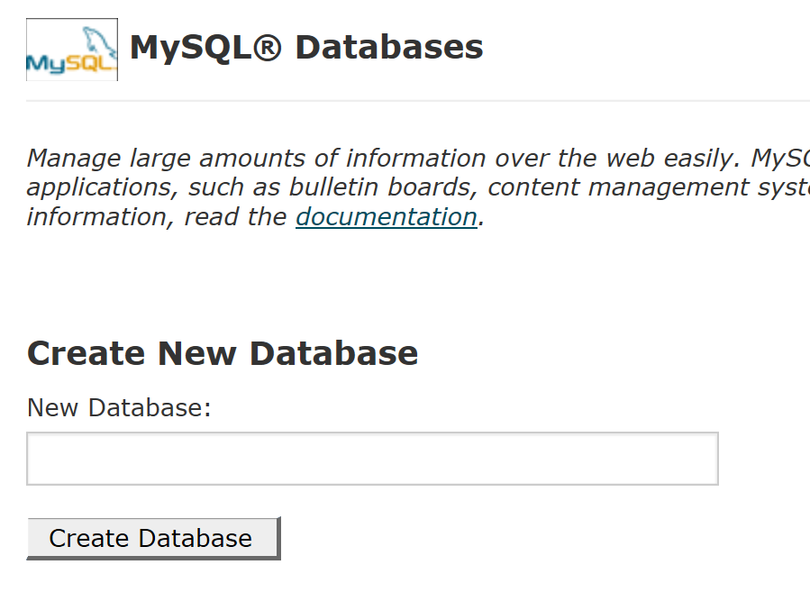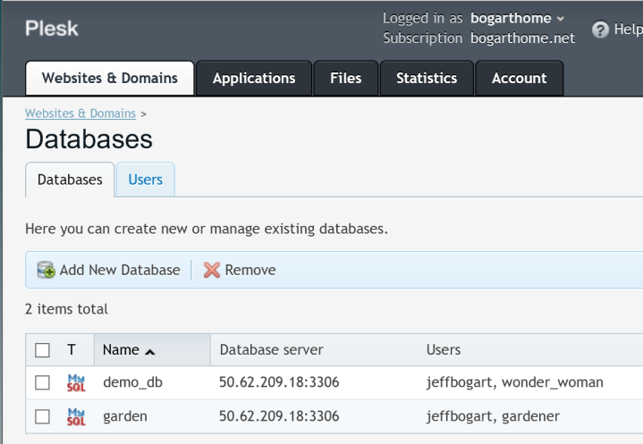
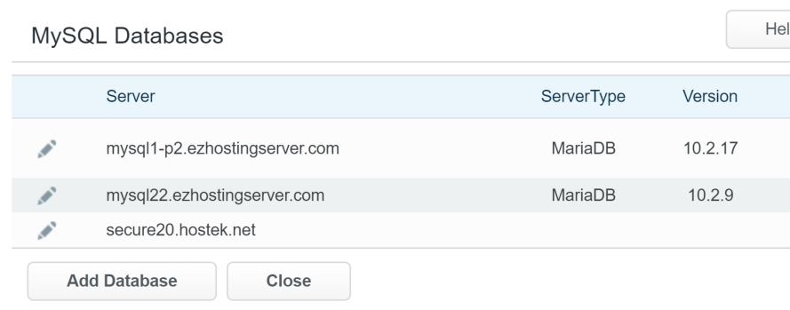
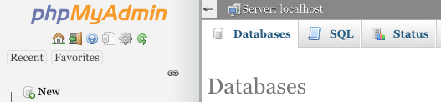

Important - Record the host name of your database (an IP address or "localhost"). You’ll need that information later.

Step 3. Create a database user name and password.
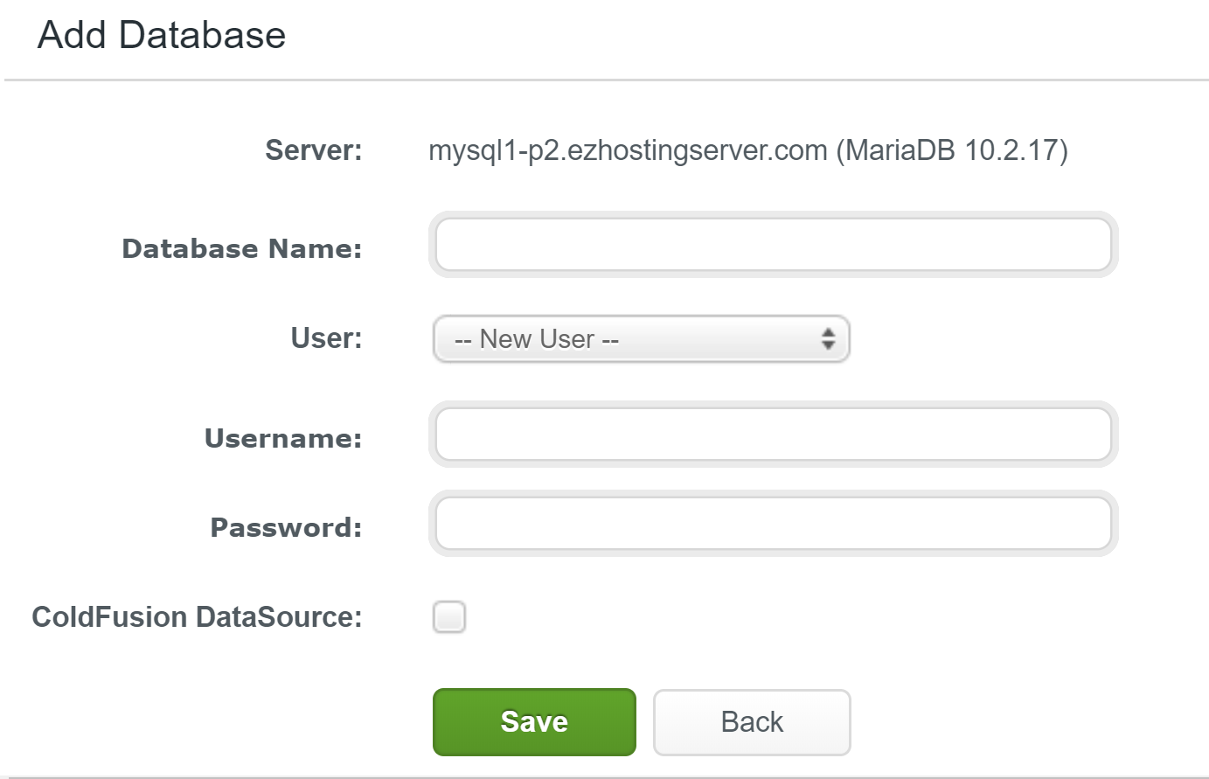
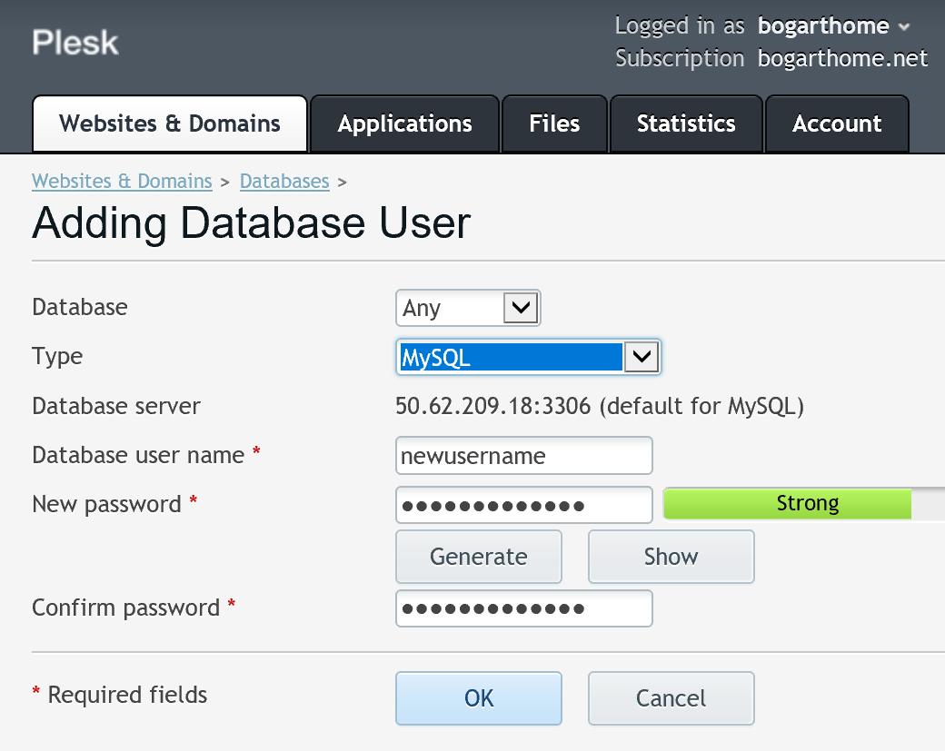
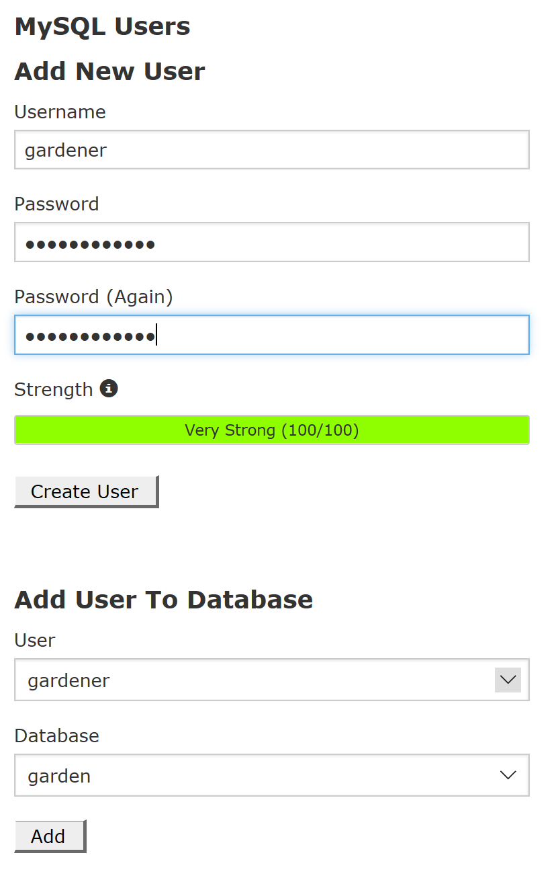

Be sure your new user has full access privileges to the database, typically the default. If you already have a user name set up for other databases, you could use that same user here of course.

Step 4: Setup
To initialize the system, invoke index.php from your browser:
http://localhost/apptsys/index.php
The page below will display. You will need to enter:
- Database host name (recorded from step 2 above).
- The database name, user name and password.
- Your personal information – name, phone, email, home site name.
(your initial password will be "admin").

The setup program will create new subfolders in your appointment folder:
- Images - all .png and .jpg files will be moved to this directory.
- appt_session_dir - where global session variables are stored.
(overrides the PHP system session location setting if it exists)
- appt_error_log – a text file where error messages may appear.
- crontab.bat – a file that is executed as a scheduled task to send email reminders.
- crontab.txt – (for future use)

The setup program will also create the database tables and their fields:
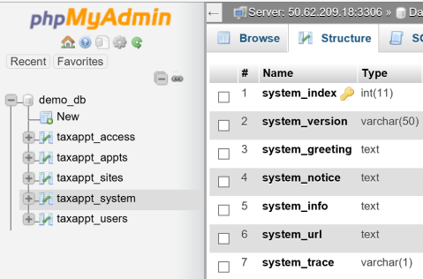
In addition to entries in the taxappt_system table, there should be one entry in the taxappt_users table (you) and two entries in the taxappt_sites table (your site and an “Unassigned” site).
The setup program will also create a new PHP file, opendb.php. This file uses the information you entered to provide the needed code statements to connect the database to the Appointment system.
If you need to run setup again for some reason, simply delete the opendb.php file and it will be re-created. Re-running setup will not change the contents of the database other than to add new tables or table fields during an update process. But it will set your password back to “admin”.

Appointment reminders:

One final step is to set up a scheduled task to run which will send email reminders to those who have upcoming appointments.
On Linux systems, that means setting up a cron job. Look for the cron icon:
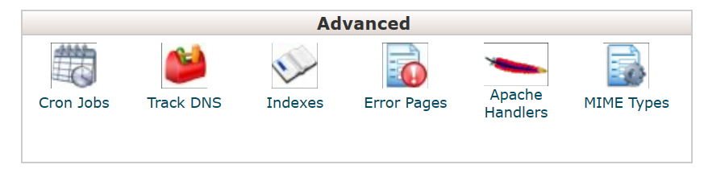
Click the Cron Jobs icon and you will be presented with a form to fill in:
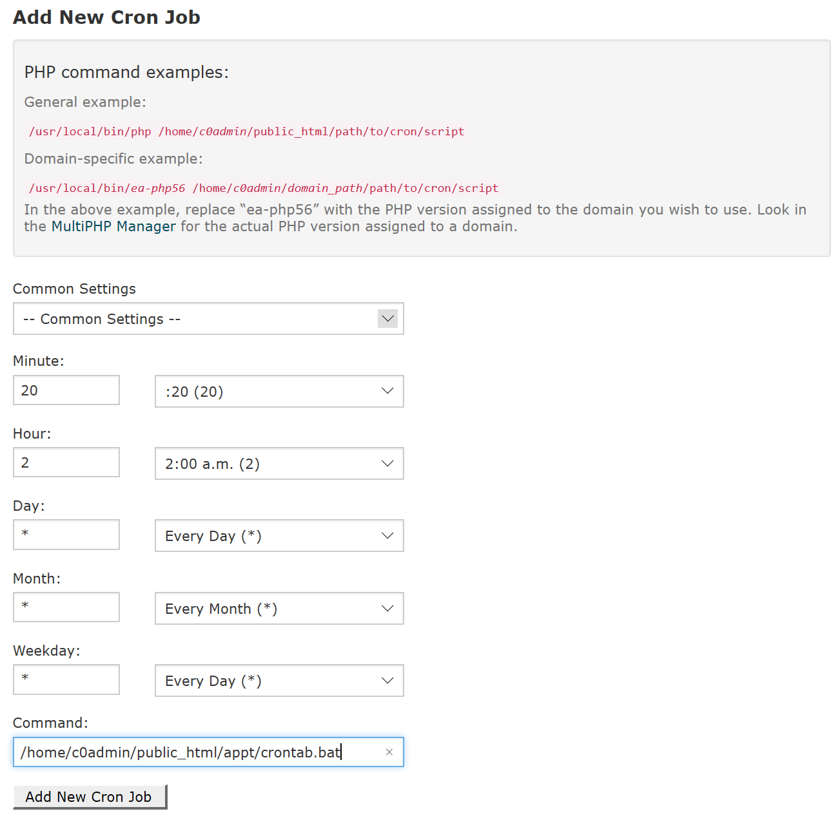
These examples are set to run at 2:20 am every day.
Note that the time set is the server time, not necessarily your local time if the server is not in your time zone.
The command entry is the full path from your home directory to the crontab.bat file that was created during the installation process.

An example Plesk screen for scheduling on a windows system:
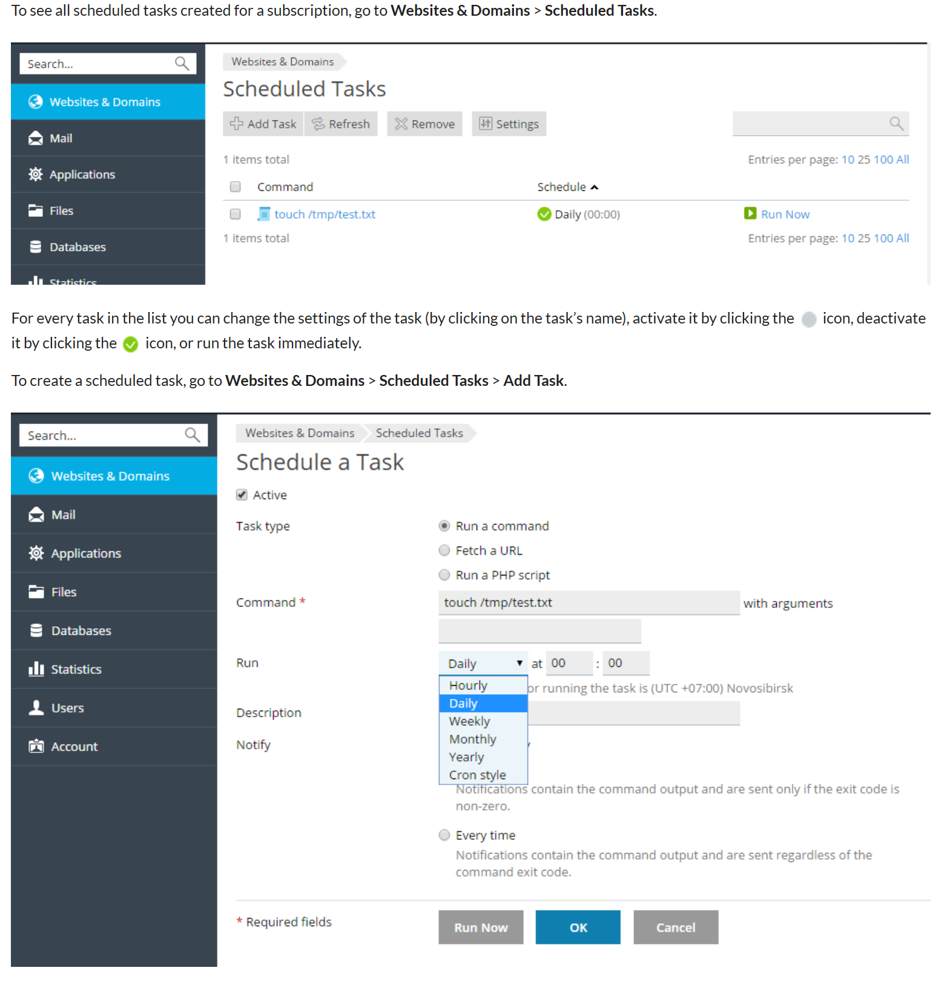

Step 5: Configuration
If setup runs properly, you will then be presented with the login page:
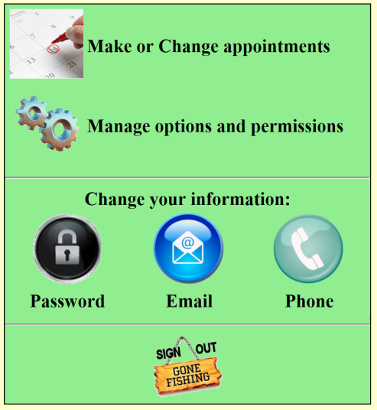
Sign in with your email and initial password (“admin”). You should change that password as soon as possible.
Then, choose “Manage options and permissions”. It will take you to your home site configuration tab.

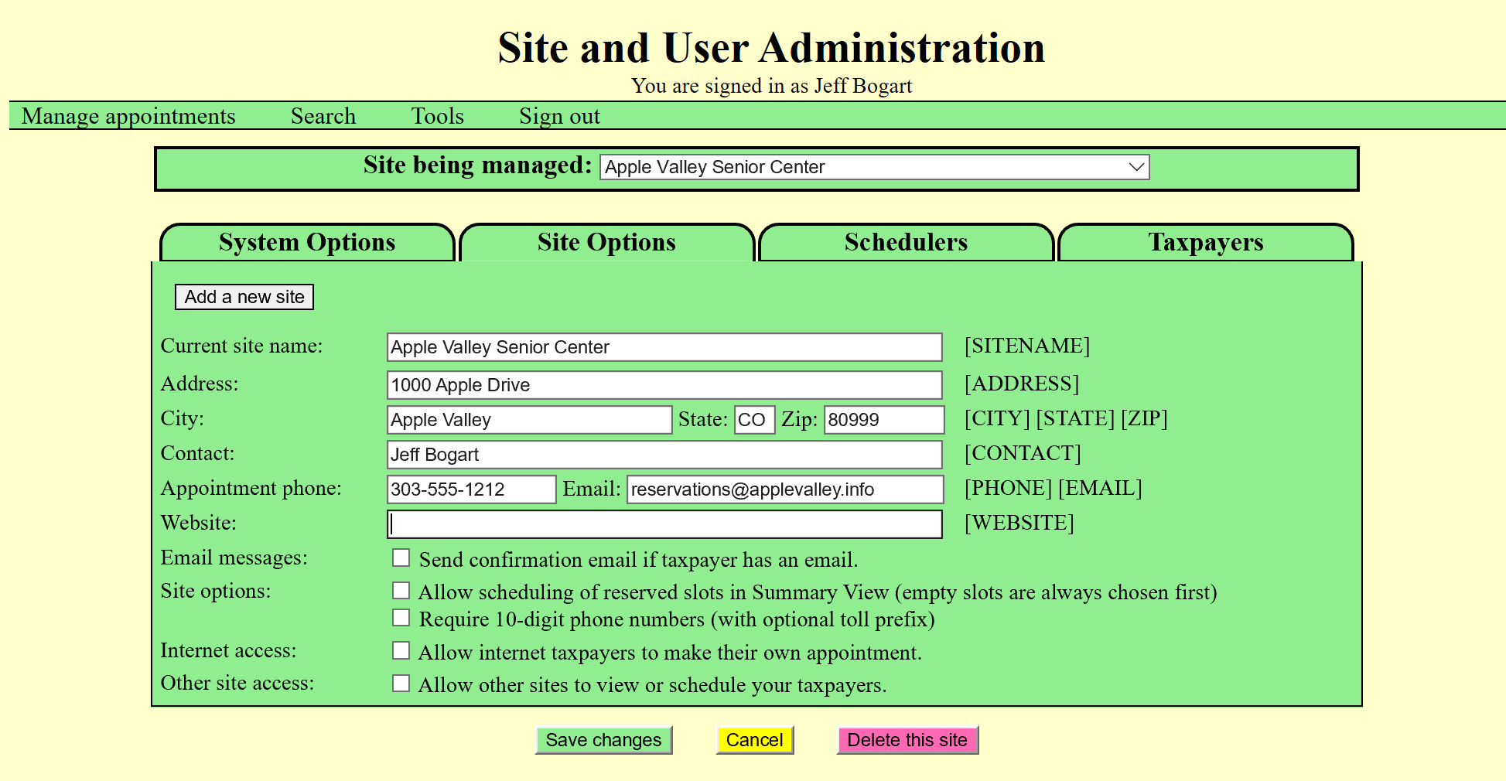

Complete filling out the information and options for your home site. More details about the options are in the Appointment help.pdf document, included as one of the TAAS files.

The System Options Tab:

As the System Administrator, you have a tab for System Options that others do not. Here, you can customize the Login Greeting, the Login Notice, the default site Confirmation message and attachment links available to the sites in their messages.
The State Website should point to a web page that is accessible to the public such as lists of what to bring. The [STATESITE] shortcode in appointment confirmation messages will be replaced by what you enter in that field.
Below the options is the Login Greeting and Login Notice setup:
The Login Greeting and Login Notices use HTML coding for the messages. To restore the default Login Greeting, simply delete the entire greeting and select Save changes (buttons will appear at the bottom of the screen). To remove the Login Notice, delete the notice and it will not appear on the login screen. The notice will have no effect on the ability to use the system but acts only as a deterrent to warn internet clients that the system is not active for their use or to indicate service limitations (for example, during the COVID epidemic period).

Scrolling down the tab gives access to the default Confirmation/Reminder message that is available to each site. Each site can create their own but if they delete their message, this will be the replacement.
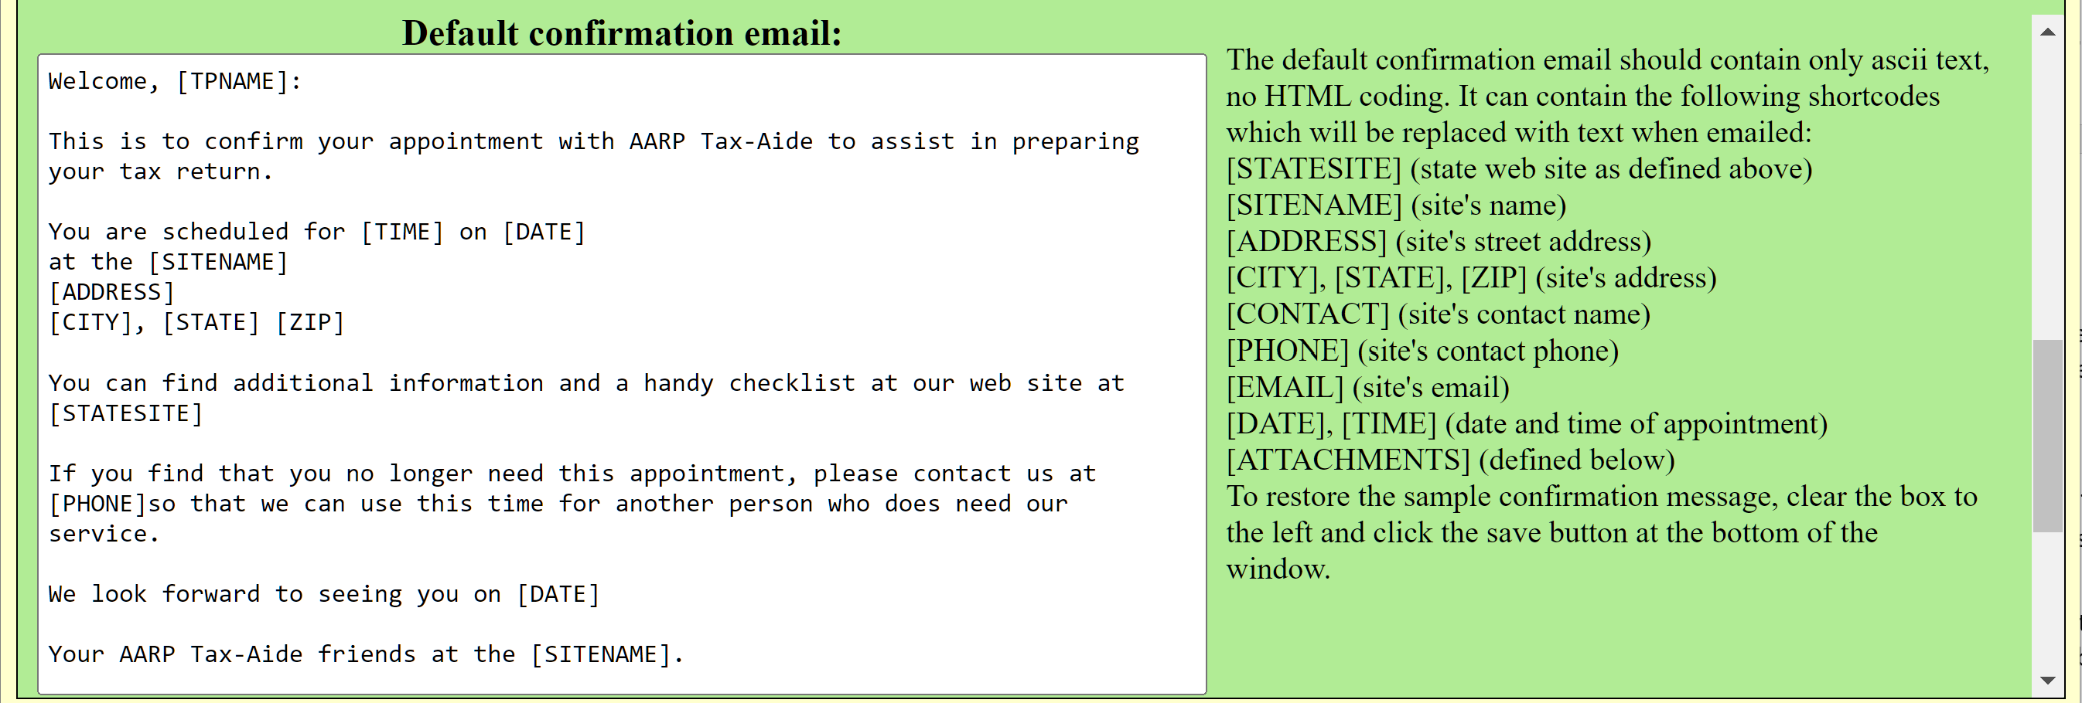
And down a little more is the definition of attachments that are available to the sites for selection using the [ATTACHMENTS] shortcode:
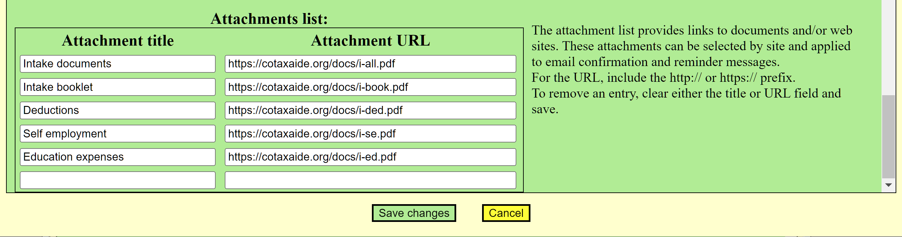
There is no limit to the number of attachments that can be defined – as you add an attachment, a new blank line will be added to the end of the list.
At the bottom of the page, save and cancel buttons will appear if changes have been made on this tab.

Also, as System Administrator, you have full access to all sites and all users and can change all permissions including adding additional System Administrators (it’s a good idea to have a backup). This can be helpful when the Appointment Managers at sites need assistance in configuring their setups.
You also have access to a site called “Unassigned”. The purpose of this site is to list users (in the Taxpayer tab) who have login accounts but are not associated with any site. Perhaps a person created a login ID but never made an appointment. You may wish to purge names on this list if they haven’t been used for a long time.

That’s it! You are now ready to add additional sites and their Appointment Managers, Schedulers and appointment slots for each site. For those tasks, see the Appointment help.pdf file included in the TAAS distribution files.

The Tools Menu:

The tools menu is only available to the Adminstrator.
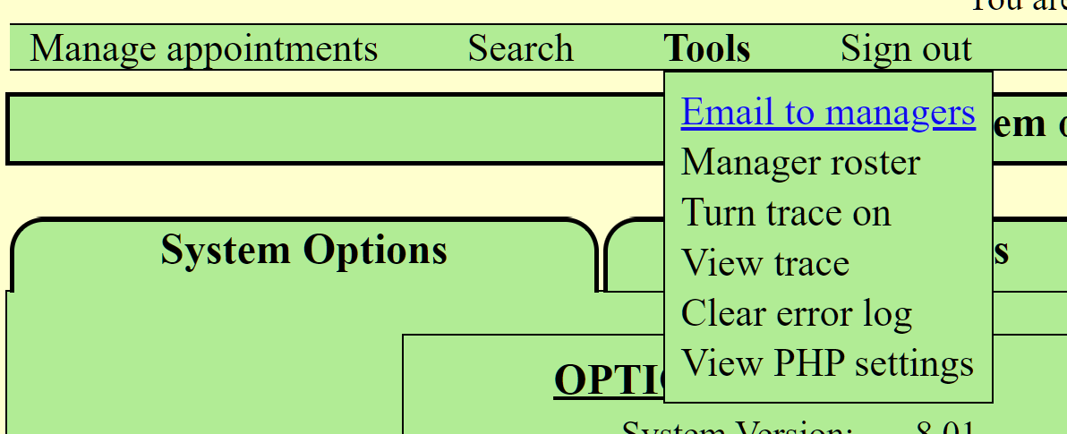
Email to managers opens your email application on your PC and pre-loads the send-to list with all Administrators and Appointment Managers.
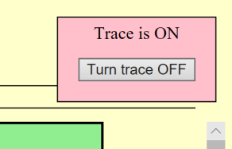
Manager roster produces a new window listing all Administrators and Appointment Managers in the system with their email address, phone number and home site name. This can be copied and pasted into an excel spreadsheet.
Turn trace on/off provides messages in the appt_error_log as an aid to troubleshooting. When the trace is active, a red indicator box at the top right of the window indicates this status. Turn the trace off by clicking the button in the red box or the Tools menu choice.
View trace provides a view of the information in the appt_error_log by grouping transactions by the user that was logged on. It can give a way to figure out who did what and when if a problem is reported.
Clear error log deletes the information in the appt_error_log. The log can get quite large as the season progresses and if all is well, there is no need to save that information. If you do wish to save the information, view the source on the browser and save it to your PC before clearing the error log.
View PHP settings provides a new window showing all settings for PHP and its extensions as an aide to troubleshooting. This invokes the show_phpinfo.php file, which can also be run directly as a URL, for example:
https://mywebsite.net/myappts/show_phpinfo.php

MacOS Installation

Step 1: Create a folder
Create a new folder to hold the Appointment system files. It’s fine to use the default MacOS Apache folder:
/Users/<username>/Sites
After you create your folder:
- Enable full permissions to this folder for your web server app and for yourself.
- Unzip and copy the files into the new folder

Then follow Steps 2 through 5 in the Windows Installation section.

Troubleshooting tips

Reporting problems
To ask questions or to report problems, please send an email to: jeff@bogarthome.net.

Check the PHP version and extensions
On your server dashboard there will be a place to select the version of PHP that is being used. The icon may be something like:

The application has been tested on several PHP versions and it’s best to use the latest (8.1 as of this writing) since the later versions have significant performance improvements.
If, during setup, the database doesn’t get created, verify that mysqli is included in the extensions.
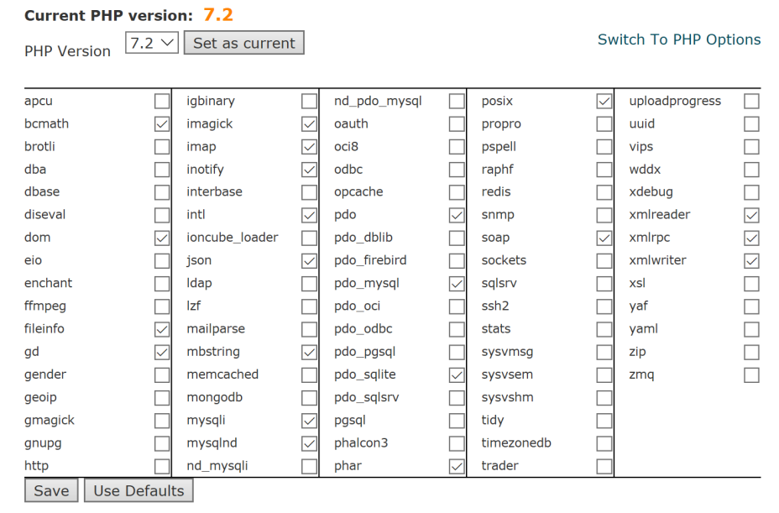

The Trace tool
From the Tools menu option, you can turn trace on or off.
This produces messages in the appt_error_log file whenever an action is taken and is helpful when the action does not do what was expected – especially if a real error is logged as a result of that action. If such occurs, please report it so that it can be investigated and repaired. Send the trace file along plus any other information that you think might be helpful.
With trace on, the appt_error_log can get rather large as time goes on. After using this tool for troubleshooting, it’s a good idea to erase the appt_error_log. It will be recreated when needed.

Environment settings
The environment.php module is designed to set the required PHP options and create the necessary subfolders.
You may gain some insight by running the show_phpinfo.php module as a URL:
https://mywebsite.net/myappts/show_phpinfo.php
If you have difficulty with the installation or operation and find a setting that is causing problems, please report it. The default settings on servers vary. We’ll be glad to help you get set up if you run into trouble.

Appendix 1 - Prerequisite Components

Windows Prerequisites
Assuming you want to use IIS as your web server, we highly recommend that you use Microsoft Web Platform Installer. It provides a robust system to install and configure many well-known web components. It works well for installing MySQL and PHP.
https://www.microsoft.com/web/downloads/platform.aspx

MacOS Prerequisites
Apache and PHP come pre-installed on MacOS. There are numerous articles available to assist you with configuring these components.
https://coolestguidesontheplanet.com/install-apache-mysql-php-on-macos-mojave-10-14/
https://www.iodocs.com/installing-apache-php-mysql-mac-os-x-macos-sierra/

MySQL
If you’re not already using MySQL, we recommend the Community Server edition.
https://dev.mysql.com/downloads/
If you install version 8.0 or greater of MySQL, we recommend you choose the Legacy Encryption option to ensure compatibility with third party tools.

Also Recommended
One of the best free database management tools for MySQL is phpMyAdmin. It is well supported and very powerful for a wide range of DBA tasks.
https://www.phpmyadmin.net/

Appendix 2 – Database Schema

Table | Field | Option | Description
taxappt_system | system_index | 1 | Only one record in this table
taxappt_system | system_version | (number) | Version number in setup.php file
taxappt_system | system_greeting | (text) | Login page greeting message
taxappt_system | system_notice | (text) | Login page notice (doesn’t print if blank)
taxappt_system | system_info |  | Reserved for future use
taxappt_system | system_url |  | URL to state web site
taxappt_system | system_trace | T | “T” if trace is active
taxappt_system | system_email |  | Default email address for emails
taxappt_system | system_reminders | (date) | The date and time when the last scheduled crontab.bat ran
taxappt_system | system_confirm | (text) | Default confirmation message
taxappt_system | system_attach | (text) | List of attachments available for use with the [ATTACHMENTS] shortcode. “|” delimits each attachment
taxappt_sites | site_index | (number) | Index of the record for the site (1 = Unassigned)
taxappt_sites | site_name | (text) | Site name
taxappt_sites | site_address | (text) | Address, phone, contact with “|” as a delimiter
taxappt_sites | site_inet | S  R  C | Internet scheduling allowed  Restrict scheduling to CB list if CB list > avail slots  Restrict scheduling to CB list
taxappt_sites | site_contact | (text) | Contact person
taxappt_sites | site_message | (text) | Email message to be sent when appt is made or changed.  Not sent if first 4 characters are “NONE”.
taxappt_sites | Site_instructions | (text) | Additional instructions for the taxpayer when making their own appointment
taxappt_sites | site_addedby | (index) | Index of site that created this site
taxappt_sites | site_open | (date) | Date site is open for internet scheduling
taxappt_sites | site_closed | (date) | Last date site is open for internet scheduling
taxappt_sites | site_schedule |  | Reserved for future use
taxappt_sites | site_help | (URL)
taxappt_sites | site_sumres | “checked” | Allow selection of RESERVED slot from Summary View
taxappt_sites | site_reminder | (number) | Number of days prior to appointment to send reminder
taxappt_sites | site_lastrem | (number) | Number of days since last email to not send a reminder
taxappt_sites | site_10dig | “checked” | 10-digit phone numbers are required
taxappt_sites | site_attach | (text) | Names of attachments to be listed using the [ATTACHMENTS] shortcode. Separated by “|”.
taxappt_users | user_index | (number) | Index of the record for this user
taxappt_users | user_name | (text) | Abbreviated name for status history messages
taxappt_users | user_email | (email) | User’s email address
taxappt_users | user_phone | (phone) | User’s phone number
taxappt_users | user_last | (text) | User’s last name
taxappt_users | user_first | (text) | User’s first name
taxappt_users | user_home | (index) | Index of user’s home site (Appt Mgrs, Schedulers only)
taxappt_users | user_appt_site | (index) | Index of user’s last appointment site (Inet scheds only)
taxappt_users | user_options | A  M  1-63 | Administrator  Appointment Manager  Bit map value of Scheduler permissions:  1 = view Callback list  2 = add/change Callback list  4 = view Appointment availability (Summary View)  8 = add/change Appointments  16 = (reserved for future use)  32 = allowed to use RESERVED slots
taxappt_users | user_lastlogin | (timestamp) | Date and time of last login
taxappt_users | user_pass |  | User password. Initial dagger indicates a temporary password sent to the user
taxappt_users | user_sitelist | (indexes) | Indexes of sites to which the user has permissions delimited with “|”
taxappt_access | acc_index | (index) | Index of the permission entry in the table
taxappt_access | acc_owner | (index) | Index of the site who has given this permission
taxappt_access | acc_location† | (index) | Index of site to whom the owner wishes to give permissions  (i.e. who is listed on the Scheduler tab)
taxappt_access | acc_user† | (index) | Index of the user to whom the owner gave permissions
taxappt_access | acc_option | M, 1-63 | The permission option (see above table)
taxappt_appts | appt_no | (index) | Index of the appointment slot
taxappt_appts | appt_date | (date) | Slot date (1900-01-01 is unused, Callback or Deleted)
taxappt_appts | appt_time | (time) | Slot time
taxappt_appts | appt_name | (text) | Client’s name
taxappt_appts | appt_location | (index) | Index of the site for which the appointment is made
taxappt_appts | appt_phone | (phone) | Client’s phone number
taxappt_appts | appt_need | (text) | Client’s need information
taxappt_appts | appt_status | (text) | Status history – each event separated by “%0A”
taxappt_appts | appt_wait | (number) | A number, used for Callback list sorting
taxappt_appts | appt_change | (timestamp) | When the appointment was last added or changed
taxappt_appts | appt_by | (text) | Full name of the person who made the appointment
taxappt_appts | appt_type | D | Deleted record
taxappt_appts | appt_tracking |  | Reserved for future use
taxappt_appts | appt_emailsent | (date) | Date when the last email was sent
taxappt_appts | appt_tags | (text) | Tags content
taxappt_appts | appt_info | (text) | Info content
taxappt_scheds | Sched_index | (index) | Index of the schedule pattern
taxappt_scheds | Sched_location | (index) | Index of the site to which the pattern belongs
taxappt_scheds | Sched_name | (text) | The name of the pattern
taxappt_scheds | Sched_pattern |  | The pattern: d1, d2 | , dow1, dow2, … | , n1, n2, n3, n1, …  d1 = starting date as yyyy-mm-dd  d2 = ending date as yyyy-mm-dd  dow1 – dow7 = Mon, Tue, Wed, etc  n1 = number of slots  n2 = time as hh:mm in 24 hr format  n3 = number of slots reserved  n1 – n3 is repeated up to 8 times as needed
†Only one of acc_user or acc_location is populated to give permissions for the user or site respectively.

Appendix 3 – Program Module Flow
reminders.php

sends email reminders as scheduled

patternsave.php

AJAX routine for saving site schedule patterns

system
sites
users
access

sitemanage.php

manages site, scheduler and internet options

includes viewtrace.php
appointment.php

manages schedules and appointment

includes showslots.php
setup.php

configures database
and updates if needed
creates opendb.php
on installation

opendb.php

connects to database
sets php timezone

environment.php
CALLED BY ALL MODULES

configures files and directories
starts a php session
sets php options
sets global variables

includes functions.php
and functions.js

appts
scheds

excelexport.php

creates db export spreadsheet window

changeopts.php

AJAX routine for scheduler options

index.php

Creates and verifies login credentials

Appendix 4 – Update History

New in version 5.00:
- Management window:
  - New option to require entry of 10-digit phone numbers.
  - New option by Scheduler to allow or deny using reserved slots for an appointment.
  - Search by name, phone or email of internet registered persons.
  - Sites are prevented from removal if any appointment slots are present – to remove a site, go to the appointment screen and “Start over” to remove all.
  - Sites are prevented from removal if any Schedulers are assigned – move them to another site or delete them.
  - New option to delete all members of the “Taxpayers” tab who have not logged in since a given date.
  - Site Appointment Managers now have access to the “Unassigned” site – a list of internet users who have created a login but have not completed a registration at any site.
  - Addition of a default system email “From” address to be used if email is sent without a site email address.
  - Ability to schedule reminder emails on a site basis (if set up for the system).
  - Administrable limit on the number of appointments an internet user can make.
- Appointment window:
  - The calendar now scrolls from the earliest appointment date to one month past the last appointment date.
  - The current date is highlighted in the calendar.
  - Schedulers can now go to an earlier than current date by clicking on the calendar day.
  - Daily view appointments now sorted by: assigned, available, RESERVED.
  - Separate the Notes field into 3 depending on desired use:
    - Tags field displays with the name on the Daily view but does not print on the check-in sheet or the ERO report.
    - Notes field continue to be footnotes on the check-in sheet,
    - Info field is miscellaneous information for Schedulers,
  - Added search by Tags option.
  - An additional column in Daily, Callback and Deleted views to indicate that the Info field has information – hover the mouse over the icon to see the information.
  - Search shows any match to phone or email at any site in the system, not just your own.
  - Allow ampersand (&) in name and email fields.
  - The status log for an appointment now shows when an email was sent.
  - The “cancel” button on the appointment entry form is now labeled “close”.
  - Deleting “Reserved for #...” entries in the Callback list no longer are added to the Deleted list.
  - Ability to save and recall a schedule pattern and use patterns saved at other sites to which you have access.
  - Ability to delete the “Deleted list”.
- Internet window:
  - The calendar was removed because it was hiding sites that could be selected and provided no additional information not already available in the list of available appointments.

New in version 6.00
- Management window:
  - A new field for each site to give additional information to the taxpayer when making their appointment.
- Internet window:
  - Display of the additional information for the site
New in version 7.00
- Management window:
  - Minor reformatting to keep table headers visible and scrolling changes
  - Minor reformatting to keep page-bottom buttons visible
  - Changed view of site messages to display in a new browser window (vs alert window)
- Appointment window:
  - Flexibility for excel export to re-order and omit selected fields
  - Added ability to copy an appointment
  - Added ability to send an email message to a taxpayer
  - Added ability to move all Callback list to Deleted list
  - Added shortcode support for site information field on user appointment window
  - Changed blue indications for internet-registered appointments
  - Minor reformatting to keep table headers visible and scrolling changes
  - Moved some routines to new functions.php, functions.js and showslots.php to reduce module size and duplication
New in version 8.00
- opendb.php problem fix
  - The line containing “mysqli_conncet_error()” has a parameter $dbcon prior to version 8. The parameter is not permitted using PHP version 8.0. This is corrected by fixdbv8.php, which is run from setup.php.
- Management window:
  - Added ability to delete the appt_error_log to prevent it getting too large or if no longer needed.
  - Added ability to tailor the default confirmation/reminder message for the system.
  - Added ability to add document or web page links as attachments to confirmation, reminder or user instruction messages via an [ATTACHMENTS] shortcode.
- Appointment window:
  - Changed export to create a download file, courtesy of Mark Doernhoefer.
  - Changed the null date (for callback and deleted record detection) from 0000-00-00 to 1900-01-01 so that database strict options work properly.
  - Added ability to select among available attachments to apply to confirmation, reminder or user instruction messages via the [ATTACHMENTS] shortcode to create a list. Individual attachments can be included in-line by placing the attachment name within brackets,
e.g: [Intake booklet]
  - Added 2 new status buttons for “Sent documents” and “Responded by email”.
- PHP 8 fixes in version 8.02
  - htmlspecialchars_decode does not accept undefined as an input so changed to always produce null if found. This change occurred in most code modules.
  - Operator === changed to == in functions.php module.

Acknowledgements:
Many thanks to the following who have provided significant assistance in creating this application:
Barry Berlin (CO1)
Bill Peterson (KS1)
Hans Jahns (ME1)
Joanne Barnard (CO1)
Maggie Barrington (CO1)
Mark Love (ME1)
Steve Anderson (KS1)
Mark Doernhoefer (CA1)

